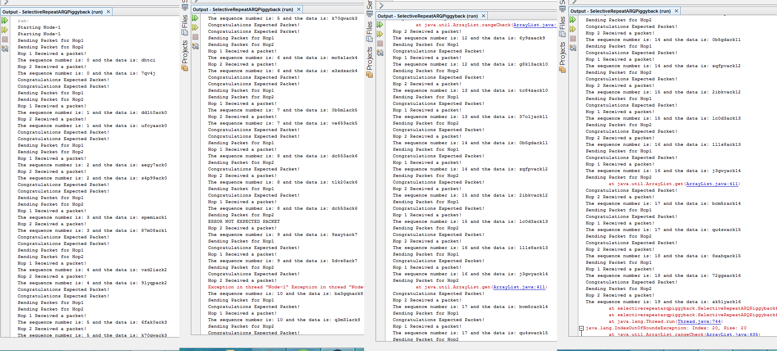

Michael Colistro

0488092

Dr El Ocla

Networking Bonus

Selective Repeat ARQ Piggybacking

Main Function

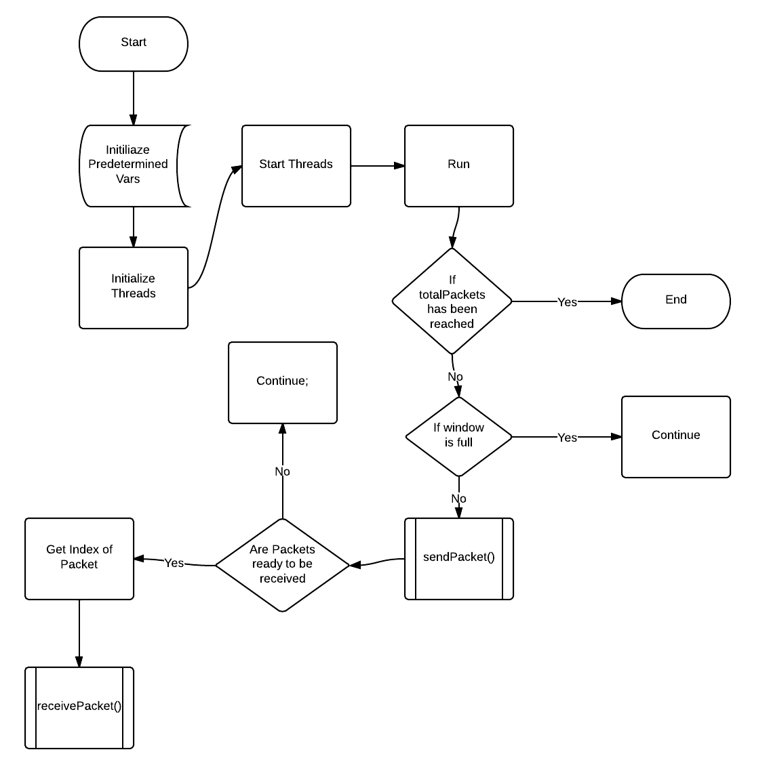

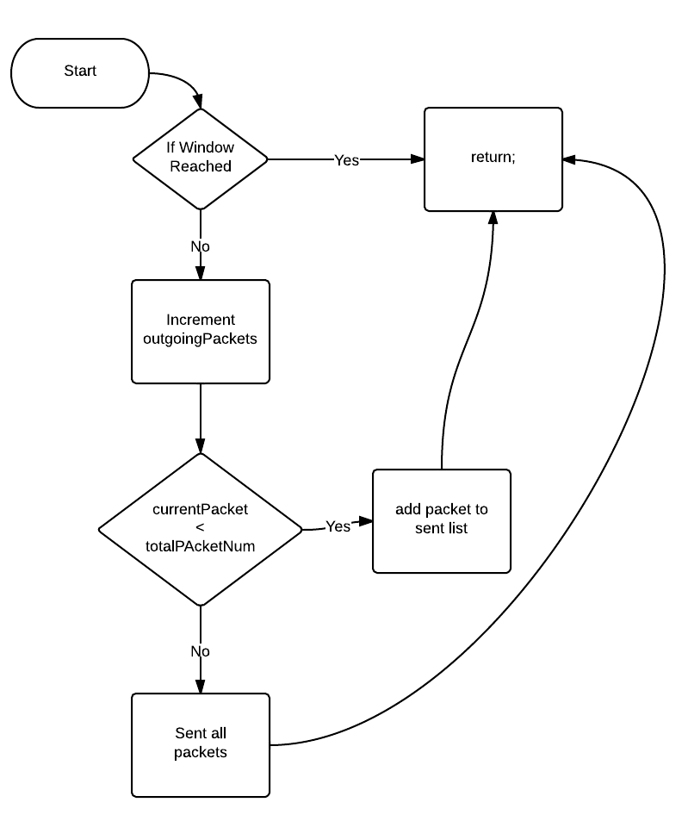sendPacket();

receive Packet();

